# 

DNA is the hereditary material in human and almost all other organisms. Deoxyribonucleic acid is a polymer composed of two polynucleotide chains that coil around each other to form a double helix .

THERE are three types of DNA

* A-form DNA
* B-form DNA
* Z-form DNA

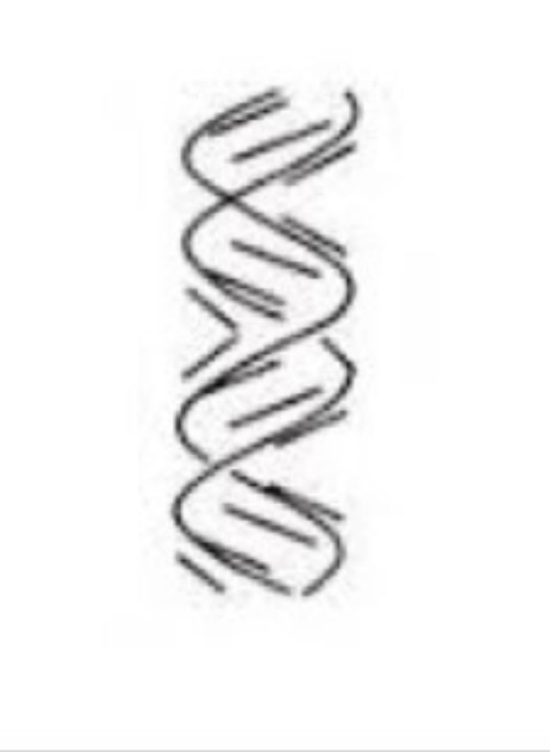A-form DNA is a right handed double helix made up of deoxyribo nucleotides . It appears when the relative humidity of the environment is less than 75 percent which means that is rarely n normal physiology conditions. The two Strands of DNA are anti-parallel with each others

And not symmetrical.The molecule is asymmetrical Because the glycosidic bonds of a base pair are Not diametrically opposite to each.

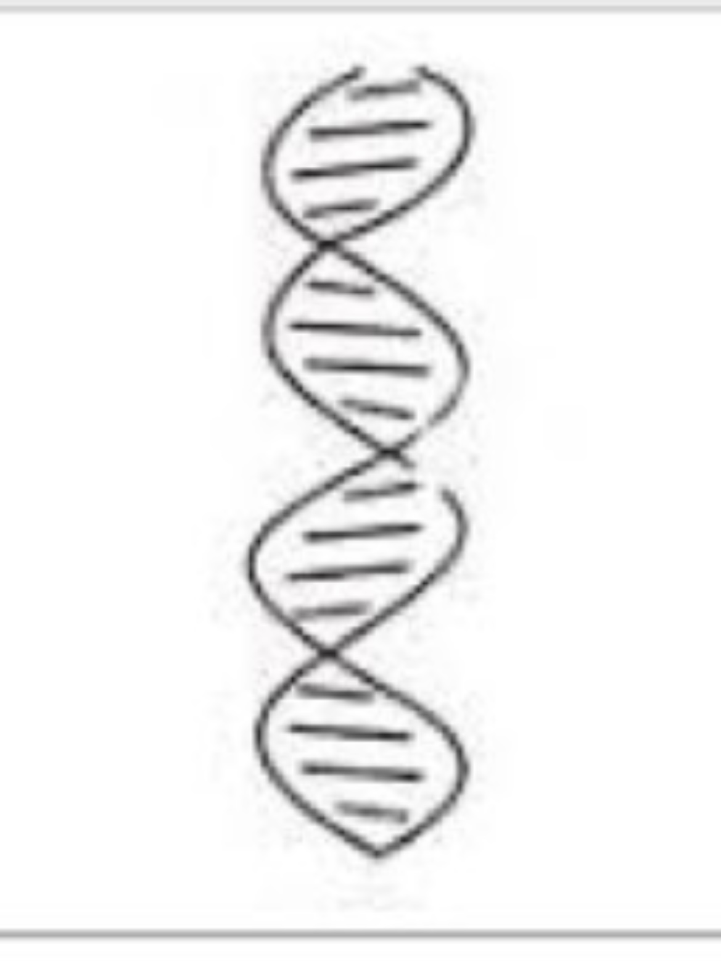B-forms DNA

B-form DNA is a right handed double helix it is the common form of vDNA exists under normal physiological conditions. The double strands of B-DNA run in opposite directions. The structure is asymmetrical with major grooves and minor grooves present alternatively. The molecules is asymmetrical because the glycosidic bonds of a base pair are not diametrically opposite to each others .

Z- form DNA

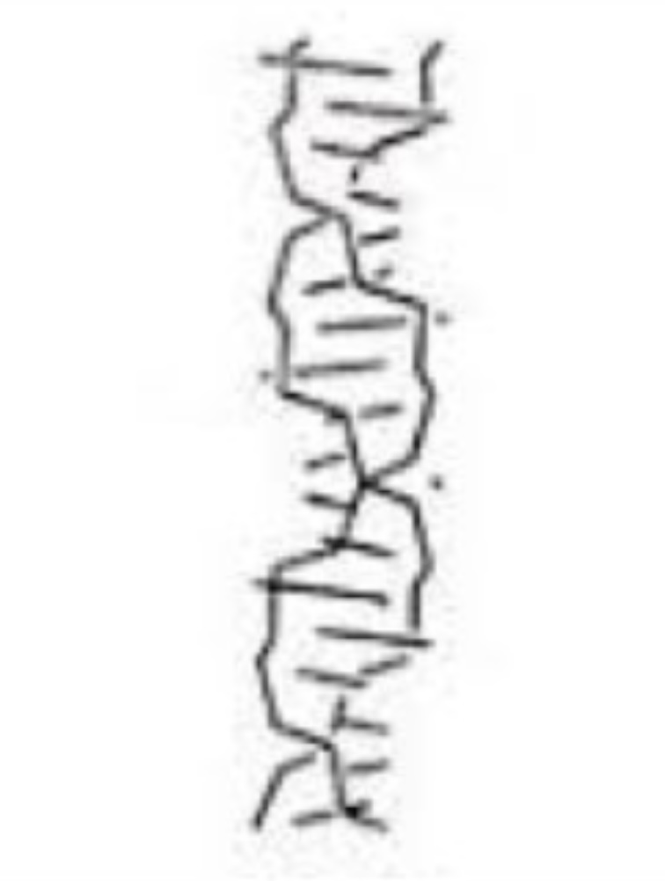Z-form DNA is a left handed double helix. It has very different structure when compared with A-DNA and B-DNA . The zigzag appearance of back bone allows it to be distinguished from other forms of DNA. The helix width is 1.8 m which is the narrowest among the 3 types .One turn of Z-DNA is difficult to be observed since it is unstable.It may take part in expression regulation of some genes or genetic recombination.

Differentiation between A-form DNA ,B-form DNA and Z-form DNA

|  |  |  |  |
| --- | --- | --- | --- |
|  | A-DNA | B- DNA | Z- DNA |
| Helical sense | Right handed | Right handed | Left handed |
| Helical tern | 11 | 10.5 | 12 |
| Major groove | Present | Present | Absent |
| Glycosyl bond conformation | Anti | Anti | Anti and syn |
| Helix rise | 2.6 | 3.4 | 3.7 |
| Base tilt | 20 degree | 6 degree | 7 degree |